Classification of Clear Cell Sarcoma as Melanoma of Soft Parts by Genomic Profiling
Neil H. Segal ¹, Paul Pavlidis², William S. Noble², Cristina R. Antonescu¹, Agnes Viale¹, Umadevi V. Wesley¹, Klaus Busam¹, Humilidad Gallardo¹, Dianne DeSantis¹, Murray F. Brennan¹, Carlos Cordon-Cardo¹, Jedd D. Wolchok¹ and Alan N. Houghton¹

Memorial Sloan-Kettering Cancer Center¹ and Columbia Genome Center, Columbia University²
New York, NY 10021

Correspondence to: N.H. Segal M.D.,Ph,D., c/o Alan N. Houghton, Memorial Sloan-Kettering Cancer Center, 1275 York Avenue, New York, NY, 10021 (e-mail: segaln01@med.nyu.edu).

Supported in part by the Etta Weinheim Memorial Fund (JDW), National Institutes of Health grant CA-47179 (MFB & ANH), Swim Across America, the Kennedy Family Fund, and National Science Foundation grant IIS-0093302 (WSN).

Running head: Genomic classification of melanoma of soft parts

Abbreviations: MSP, melanoma of soft parts; CCS, clear cell sarcoma; STS, soft tissue sarcoma.

Abstract
Purpose: The aim of this study was to develop a genome-based classification scheme for clear cell sarcoma (CCS), also known as melanoma of soft parts (MSP), which would have implications for diagnosis and treatment. This tumor displays characteristic features of soft tissue sarcoma, including deep soft tissue primary location and a characteristic translocation, t(12;22)(q13;q12) involving EWS and ATF1 genes. CCS/MSP also has typical melanoma features, including immunoreactivity for S100 and HMB45, pigmentation, MITF-M expression and a propensity for regional lymph node metastases. Methods: RNA samples from 21 cell lines and 60 pathologically confirmed cases of soft tissue sarcoma, melanoma and CCS/MSP were examined using the Affymetrix® U95A GeneChip. Hierarchical cluster analysis, principal component analysis and support vector machine analysis exploited genomic correlations within the data to classify CCS/MSP. Results: Unsupervised analyses demonstrated a clear distinction between STS and melanoma, and furthermore showed CCS/MSP to cluster with the melanomas as a distinct group. A supervised support vector machine learning approach further validated this finding and provided a user-independent approach to diagnosis. Genes of interest that discriminate CCS/MSP included those encoding melanocyte differentiation antigens, MITF, SOX10, ERBB3 and FGFR1. Conclusion: Gene expression profiles support the classification of CCS/MSP as a distinct genomic subtype of melanoma. Gene profiles may be useful using the support vector machine for diagnosis. Genomic analysis identified potential targets for the development of therapeutic strategies in the treatment of this disease.
Introduction
Clear cell sarcoma (CCS), also known as melanoma of the soft parts (MSP) is an unusual malignancy of adolescents and young adults, typically arising in the deep soft tissues of the lower extremities close to tendon, fascia and aponeuroses. CCS was originally described by Enzinger ¹ in 1965 as a soft tissue sarcoma (STS). This classification was reconsidered in 1983 when Chung and Enzinger ² changed its nomenclature to melanoma of soft parts (MSP). MSP was proposed to arise from a progenitor neural crest cell with the potential for melanocytic differentiation and melanin synthesis. Melanocyte progenitors normally migrate from the neural crest to the basal layer of the epidermis. In this case, the progenitor cell may not reach its final destination during embryogenesis and remains within the deeper soft tissues.
The clinical behavior of CCS/MSP demonstrates features that resemble both melanoma and STS. Like melanoma, CCS/MSP shows a propensity for regional lymph node metastasis, but lacks a typical melanoma-like diffuse pattern of distant metastatic spread. Whereas, this cancer resembles STS by virtue of its deep soft tissue primary location, lack of cutaneous invasion and predilection for pulmonary metastasis.
On pathologic examination, CCS/MSP are positive by immunohistochemistry for melanoma markers HMB45 and S100 and contain a mixture of both stage II (unpigmented) and stage III (pigmented) melanosomes on ultrastructural analysis ³⁻⁶. In addition, CCS/MSP typically express the melanoma isoform of microphthalmia transcription factor (MITF-M) ⁴. MITF-M isoform is a transcription factor that is required for melanocytic differentiation and induces the expression of melanocyte differentiation molecules ⁷⁻⁹.
On the other hand, similar to a subset of STS, CCS/MSP is characterized cytogenetically by a distinct and recurrent chromosomal translocation, t(12;22)(q13;q12) as the characteristic genetic abnormality, recombining the 5` region of the EWS gene on chromosome region 22q12 with the 3` region of ATF1 on 12q13 ¹⁰. The resulting fusion product places the carboxy terminus of ATF1 under the constitutive regulation of the EWS activation domain containing repetitive repeats. This region of ATF1 contains a functional bZIP DNA binding and dimerization domain, a transcription factor normally regulated by cAMP, resulting in the constitutive activation of several cAMP-inducible promoters ^{11,12}.
Previous studies have attempted to define CCS/MSP according to known markers of the melanocytic lineage and conventional ultrastructural and karyotypic analyses. We have applied global gene expression analysis to address the question of classification. Using the Affymetrix® oligonucleotide array platform, we explored three independent bioinformatic approaches and showed that CCS/MSP fits as a distinct genomic subtype of melanoma, with implications for future therapeutic strategies.

Materials and methods
Specimen collection
Tissue specimens were obtained from 60 patients undergoing surgery at Memorial Sloan-Kettering Cancer Center (MSKCC), in addition to 21 cell lines established at this institute. All specimens were collected under a tissue procurement protocol reviewed and approved by the MSKCC Institutional Review Board. Representative tumor tissue was embedded in OCT compound and frozen as tissue blocks using liquid nitrogen. Tumor specimens were selected for analysis according to validation of histologic diagnosis. Twenty melanoma cell lines were established from melanoma specimens of 20 independent patients from regional and distant metastases ¹³. A CCS/MSP cell line was derived in primary culture from a tumor specimen included in this study. Normal tissue RNA was obtained from Stratagene (La Jolla, CA) and Clontech (San Jose, CA). For additional details on specimens, see supplementary information at www.mskcc.org/genomic/ccsmsp.
Histologic and molecular diagnosis
In all four CCS/MSP tumor specimens and the one derived cell line, histologic slides and immunostains were reviewed for confirmation of pathologic diagnosis. The presence of the EWS-ATF1 fusion transcript was tested and confirmed in each case, as previously reported ⁴.
GeneChip® analysis
Cryopreserved tumor sections were homogenized under liquid nitrogen by mortar and pestle. Total RNA was extracted in Trizol reagent and purified using the Qiagen Rneasy kit. RNA quality was assessed on ethidium bromide agarose gel electrophoresis. cDNA was then synthesized in the presence of oligo(dT)24-T7 from Genset Corp. (La Jolla, CA). cRNA was prepared using biotinylated UTP and CTP and hybridized to HG_U95A oligonucleotide arrays (Affymetrix Inc., Santa Clara, CA). Fluorescence was measured by laser confocal scanner (Agilent, Palo Alto, CA) and converted to signal intensity by means of Affymetrix Microarray Suite v5.0 software. For complete expression data, see supplementary information.
Hierarchical cluster analysis and principal component analysis
Hierarchical cluster analysis was performed using XCluster (http://genome-www.stanford.edu/~sherlock/cluster.html), using a centered Pearson correlation coefficient distance metric and average linkage to measure cluster distances during partitioning ¹⁴. A nonparametric bootstrap was used to estimate confidence of the cluster structure ¹⁵. For each bootstrap sample, the clustering obtained was compared to the clustering obtained with the original data set. Two clusters (branches of the hierarchy) were considered identical if they contained the same members. By observing the behavior of individual samples from trial to trial, additional insight could be gained into the structure of the data. That is, individual samples could be identified that contributed to the stability (or lack thereof) of particular clusters. A standard principal components analysis was performed on the full data set. Projections of the data on the principal components were visualized with Xgobi ¹⁶.
Support vector machine analysis (SVM)
The ability of a machine-learning algorithm to correctly classify each tumor type was measured using SVM analysis with hold-one-out cross-validation ^{17,18}. In brief, during the training phase the SVM takes as input a microarray data matrix, and labels each sample as either belonging to a given class (positive) or not (negative). The SVM treats each sample in the matrix as a point in a high-dimensional feature space, where the number of genes on the microarray determines the dimensionality of the space. The SVM learning algorithm then identifies a hyperplane in this space that best separates the positive and negative training examples. The trained SVM can then be used to make predictions about a test sample’s membership in the class. We used a standard ‘hold-one-out’ training/testing scheme, in which the SVM is trained separately on training sets made up of all but one of the samples, and then tested on the single ‘held out’ sample. This approach allows us to collect unbiased measurements of the ability of the SVM to classify each sample. Because a classifier’s performance can be hindered by the inclusion of irrelevant data, we used feature selection to identify genes that are most important for classification. The genes in the training data set were ranked in order of their proposed importance in distinguishing the positives from the negatives, as described in more detail in the next section, and the top N genes were taken for each trial. The value N was varied in 12 powers of 2, ranging from 4 to 8192. Thus, the SVM was run 51 times on each of 12 different numbers of features (genes), for each of the tumor classes. Each held-out test sample was counted as either a false positive, false negative, true positive or true negative.
Gene ranking for feature selection
To select genes that were the most informative for the SVM, we tested a variety of methods including the Fisher score method ¹⁷ and parametric and nonparametric statistics. Data reported here were derived from the Student’s t-test, because it yielded the best SVM performance overall. Each gene in each training data set was subjected to the following procedure. A standard Student’s t-test was used to compare the expression in one tumor type to that in the remaining samples. The resulting p-values were then used to rank the genes, and the desired number of genes was then selected for use. The corresponding data from the training set was used to train the SVM, and the same genes were used for the test data. It is important to note that the genes were selected solely on the basis of the training data. Finally, a t-test statistic as determined for all samples was used to provide an overall ranking of the genes in order of relevance for each tumor classification. This ranking was used to provide an overview of the most important genes for distinguishing the class.

Results
Cluster Analysis
We measured the gene expression profile of 81 tumor specimens and cell lines using 12,559 oligonucleotide probe sets on the U95A GeneChip from Affymetrix®. Specimens included five CCS/MSP (4 tumor specimens and one established cell line), 29 melanomas (9 tumor specimens and 20 established cell lines) and 47 STS (all tumor specimens). The STS specimens, recently examined in an independent study in tumor classification, included leiomyosarcoma, gastrointestinal stromal tumor (GIST), synovial sarcoma, malignant fibrous histiocytoma (MFH), conventional fibrosarcoma, pleomorphic liposarcoma, dedifferentiated liposarcoma and myxoid/round cell liposarcoma. We explored three independent approaches to determine whether global gene expression profiling could discriminate STS from melanoma, and potentially classify CCS/MSP.
We initially performed hierarchical cluster analysis to group specimens on the basis of similarity in gene expression profile. Remarkably, this analysis clearly discriminated STS and melanoma, and furthermore showed CCS/MSP to cluster with the melanomas as a distinct group (Fig. 1). We used a bootstrap analysis to generate estimates of the robustness of the clusters. In this analysis, multiple resampled data sets are generated by sampling from the data at random with replacement. This revealed that some specimens were not stable. Such specimens grouped in different trials with either the principal STS or melanoma clusters. In particular melanoma specimens M1, M2, M5, M6 and M9 relocated 13, 49, 9, 41 and 41 times respectively. A single dedifferentiated liposarcoma specimen (S28) clustered with the melanomas. Further histologic review of this STS specimen did not find any features to suggest melanocytic differentiation. In the same bootstrap analysis, all CCS/MSP specimens remained within the melanoma cluster in all 100 resampled data sets.
Principal Component Analysis

We applied a second unsupervised analysis in order to further establish the interrelationships of the samples. By visualizing projections of the data into low-dimensional spaces defined by a principal components analysis (PCA), we could observe groupings of samples reflecting underlying patterns in the expression data. The first three components, which accounted for approximately 17% of variance in the data, facilitated separation of the STS and melanoma samples (Fig. 2a). In agreement with the clustering results, CCS/MSP grouped with the melanomas in this analysis. Additional component vectors accounting for a further 12% of variability within the data were highly correlated with GIST, synovial sarcoma and round cell liposarcoma groups (data not shown). Of particular interest, component 8, accounting for approximately 2.5% of the variance, enabled separation of the CCS/MSP samples from the remaining melanoma specimens (Fig. 2b).
Supervised Machine Learning Diagnosis

We then applied a supervised machine-learning algorithm to the diagnosis of CCS/MSP. We trained a Support Vector Machine (SVM) to distinguish between melanoma and STS by the identification of a hyperplane that best discriminated these specimens. The learning efficacy of this algorithm was demonstrated in a leave-one-out cross validation approach in which each of the 76 training specimens became unknown to the machine during both the training and predictive stages. Using 256 features (genes), SVM predicted the correct diagnosis in all STS specimens and 28 of 29 melanomas, i.e., 98.5% positive predictive value. Remarkably, all CCS/MSP specimens were classified as melanomas on testing with the trained SVM (Fig. 3).

Genes with Potential Biological and Therapeutic Relevance

We used Student’s t-test analysis to identify genes for biological discovery. The top-scoring 30 genes that discriminate CCS/MSP from STS and melanoma were cross-referenced against both the published literature and the gene ontology consortium database (http://www.geneontology.org/) using Netaffx® (http://www.affymetrix.com). We discovered several genes that are implicated in diverse biological processes, pathways and states of differentiation (fig. 4).
Genes that discriminated CCS/MSP from STS included those implicated in cell adhesion, CTNNA1; cell cycle control, CDK2; synaptic transmission, CNP and PLP1; transcriptional activation, SOX10 and AREB; intracellular signaling, STC1; cell proliferation, TCF8; and the epidermal growth factor receptor, ERBB3/HER3.
Genes that discriminated CCS/MSP from the remaining melanoma included the cAMP responsive element modulator, CREM; fibroblast growth factor receptor, FGFR1; insulin-like growth factor binding proteins, IGFBP4 and IGFBP5; and proto-oncogenes, c-mer and FYN.
A subset of gene were shown to discriminate CCS/MSP from both STS and melanoma, including the small monomeric GTPase, RABB33; proto-oncogene, MERTK; glycopeptide hormone, stanniocalcin 1 and the neuropeptide, galanin.
Melanoma differentiation antigens

We further surveyed specific genes of interest and found melanoma differentiation antigens TYRP1, TYRP2/DCT and MART-1 to be expressed at varying levels in the CCS/MSP specimens. PMEL17 was most consistently expressed in all four tumors in a similar distribution to MITF. Interestingly, SOX10, which induces MITF expression ¹⁹, was expressed in all CCS/MSP and most melanoma specimens (Fig. 5).
Discussion

CCS/MSP can be difficult to distinguish from malignant peripheral nerve sheath tumors (MPNST), primary nodular cutaneous melanoma and cutaneous melanoma metastatic to soft tissues. CCS/MSP is distinguished from MPNST by the association of the latter with nerve trunks and the presence of basal lamina around tumor cells of MPNST. Immunohistochemistry is also helpful, since amelanotic MPNST is usually negative for gp100 (encoded by PMEL17), while this melanocyte differentiation marker is usually detected in CCS/MSP. The distinction of CCS/MSP from cutaneous melanoma is more difficult, since the tumors share similar light microscopic, ultrastructural and immunohistochemical features. If a precursor lesion, such as in situ melanoma or a nevus is associated with a spindle cell melanoma, the diagnosis of a primary cutaneous melanoma is straightforward. In the absence of a precursor lesion, CCS/MSP is distinguished from a primary cutaneous melanoma primarily by its anatomic location and clinical features. If a solitary melanocytic tumor is centered in deep subcutis, associated with tendinous tissue and there is no history of a prior cutaneous melanoma, the findings favor CCS/MSP. In contrast, a primary cutaneous nodular melanoma is usually a dermal-based tumor. Melanoma metastases to soft tissue derived from primary cutaneous tumors rarely occur in the absence of other evidence of metastatic disease and the tumors tend to be more pleomorphic and mitotically active than CCS/MSP.
In difficult cases, genetic studies are of diagnostic help. Most cutaneous melanomas are markedly aneuploid ²⁰ and frequently demonstrate diverse genetic alterations commonly involving chromosomes 1 and 5, and deletion of 6q ^{21,22}. CCS/MSP are most often diploid or mildly aneuploid ²⁰ and contain the characteristic translocation, t(12;22)(q13;q12) involving EWS and ATF1. Confirming data in the literature shows this alteration to be both a sensitive and specific marker for CCS/MSP, and is found in no cases of malignant melanoma ²¹. Furthermore, CCS/MSP may demonstrate unusual histology, including an alveolar growth pattern or rhabdoid cells with significant nuclear pleomorphism ⁴. Despite these features being typical in STS, previous reports have shown both immunohistochemical and ultrastructural data to support CCS/MSP as a neuroectodermal tumor with melanocytic differentiation ^{3,5,23}.
In this study, we show that a genomic approach to cancer classification can further clarify previously controversial diagnostic categories. Indeed, the introduction of gene expression profile analysis calls for a revised approach in the categorization of CCS/MSP. The unsupervised analyses in this study divide malignant melanoma and soft tissue sarcoma on the basis of distinct gene expression profiles. Notwithstanding the fact that CCS/MSP is characterized by a sarcoma-like translocation, the gene expression profile of this tumor is more highly correlated with that of melanoma. This genomic classification extends beyond a handful of genetic and morphological features to incorporate the information provided by thousands of genes. CCS/MSP consistently behaved as melanomas during all boot-strapping iterations in hierarchical cluster analysis. In contrast, several melanoma specimens were observed to occasionally cluster with the STS in a subset of these analyses using the same random genes. This observation provided reassurance that the CCS/MSP specimens were even more “melanoma-like” than these melanoma specimens.
In addition, we have shown SVM analysis to predict the precise classification of unknown specimens using data from two distinct groups, without incorporating any additional information from the unknown case. This method is unlike the unsupervised approaches above, in which information from all specimens was taken into account when determining their genomic relationship and potentially influencing the outcome. The results of this diagnostic algorithm showed CCS/MSP once more to be decidedly in the melanoma group. The observation that CCS/MSP is grouped or classified with melanoma in all analytical approached used in this study is quite convincing.
It is of interest that the one melanoma which displayed the greatest tendency to cluster as a STS, was a spindle cell desmoplastic and neurotropic melanoma. This type of melanoma clinically often behaves similar to many sarcomas in that it is less likely to spread to lymph nodes and more likely to recur locally or metastasize to visceral sites, such as the lung, without associated nodal involvement.
One of the clearest distinctions in gene expression between CCS/MSP and STS involved genes of melanocyte differentiation. In particular, all CCS/MSP tumor specimens expressed MITF and PMEL17, whereas MELAN-A/MART-1, DCT and TYR were differentially expressed in varying tumor subsets. SOX10, which has been reported to induce expression of MITF ²⁴, is expressed in all CCS/MSP and the majority of melanoma specimens. Another SOX10 inducible gene, ERBB3/HER3 ¹⁹, followed a similar expression pattern. This suggests that control of melanocytic differentiation may be considered at an earlier step than previously attributed to MITF in this tumor type. Of interest, SOX10 has recently been shown to be recognized by tumor-infiltrating lymphocytes in an HLA-A2-restricted fashion ²⁵.
FGFR1, shown here to be expressed in CCS/MSP, is particularly significant considering its role in angiogenesis, migration and tumor growth. The prototype FGF family member, FGF2, is a ligand of FGFR1 and a potent mitogen in diverse cell types including vascular endothelial cells and fibroblasts. In addition, FGF2 has been reported to act synergistically with VEGF and to induce its expression, reviewed in ²⁶. SU668, a potent inhibitor of tyrosine kinase activity, inhibits FGFR as well as Flk-1/KDR (the VEGF receptor), as well as tumor vascularization and growth of melanoma xenografts ²⁷. These data are quite compelling to further investigate the effect of SU668 in the treatment of CCS/MSP.
In conclusion, gene expression profile analysis provides a unique perspective into the classification of CCS/MSP. Using three separate analytical approaches, we have shown that CCS/MSP is a distinct genomic subtype of melanoma. Our conclusion is supported by previous studies using morphologic criteria, genotypic analysis and immunophenotypic markers ³⁻⁶. Not only do these findings have biological significance but practical treatment options. STS are commonly treated with adjuvant radiation therapy, which has been shown to decrease local recurrence in randomized trial ²⁸. Local radiation is rarely, if ever indicated in melanoma. Furthermore, we have implicated several molecules in CCS/MSP that may be potential therapeutic targets. In particular pMEL17, TYRP2/DCT, Melan-A/MART-1 and SOX10 could be considered for cancer vaccine strategies, and FGFR1 as the target of the tyrosine kinase inhibitor SU6668.
Acknowledgments
We are very grateful to Juan Li and Liliana Villafania of the Genomic Core Laboratory; Barbara Kaye-Injeian, Alwyn Maynard, Raul Meliton and Cora Mariano of the tumor procurement service, and Maria Dudas of the Department of molecular Pathology. We would also like to acknowledge the Laboratories of the Division of Molecular Pathology, Memorial Sloan-Kettering Cancer Center, for the EWS-ATF1 results.
Fig 1. Hierarchical cluster analysis of 81 tumor and cell line specimens using ~12,500 genes on the Affymetrix® U95A GeneChip. Two principal clusters corresponded to melanoma and soft tissue sarcoma. CCS/MSP clustered with the melanomas as a distinct group. A dedifferentiated liposarcoma clustered within the melanoma group.

Fig 2. The relationship between melanoma (yellow), soft tissue sarcoma (blue) and CCS/MSP (red) by principal component analysis. Each case is represented by a colored sphere, the distance between cases inversely reflects their degree of relatedness in low dimensional space defined by various principal components.

Fig 3. This one-dimensional plot of support vector machine discriminant values (on left) shows each of the STS (blue) and melanoma (yellow) specimens during the validation stage with a 98.5% positive predictive value. All CCS/MSP (red) specimens were classified as melanoma during the prediction stage.
Fig 4. Identification of genes for biological discovery. The top 30 genes that discriminate CCS/MSP from melanoma (left) and STS (right) scored by Student’s t-test analysis and sorted by increasing p-value (shown as negative log). Light to dark color variation represents high to low levels of expression.

Fig 5. Expression panel of melanoma differentiation antigens as well as associated factors, MITF and SOX10, demonstrates variability in expression level in STS (left), melanoma (middle), CCS/MSP (highlighted) and adult and fetal normal tissues (right).

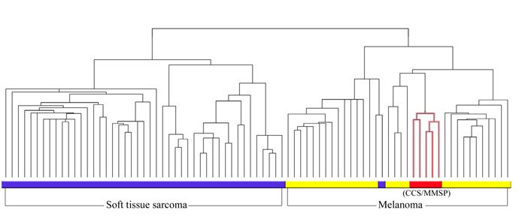

Fig. 1.

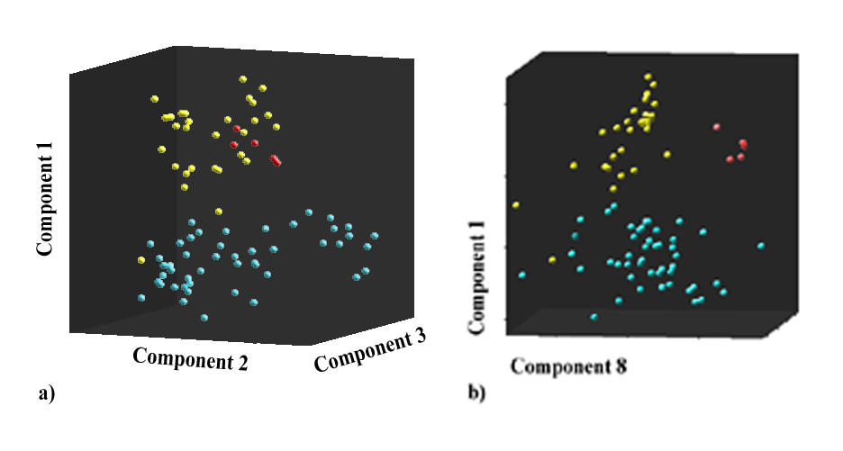

Fig. 2.

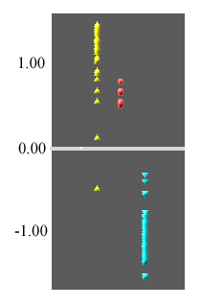

Fig. 3.

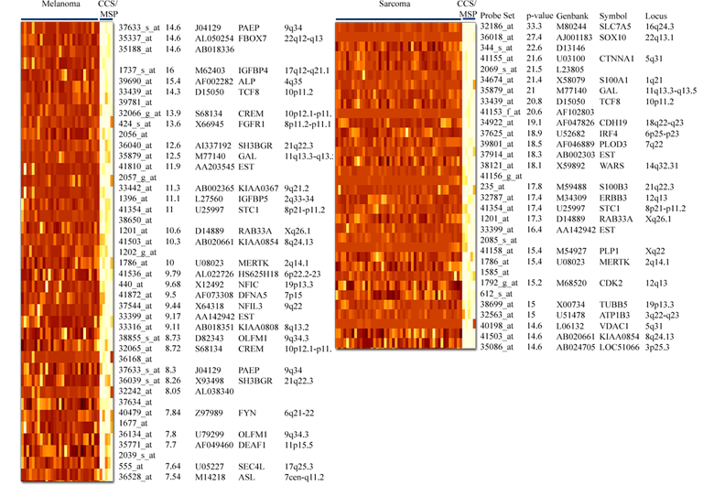

Fig. 4.

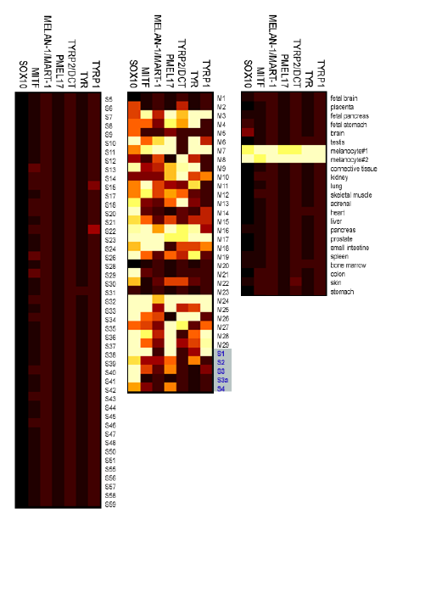
Fig. 5.

References
1. Enzinger FM: Clear cell sarcoma of tendons and aponeuroses: an analysis of 21 cases. Cancer 18:1163-1174, 1965
2. Chung EB, Enzinger FM: Malignant melanoma of soft parts. A reassessment of clear cell sarcoma. Am J Surg Pathol 7:405-13., 1983
3. Benson JD, Kraemer BB, Mackay B: Malignant melanoma of soft parts: an ultrastructural study of four cases. Ultrastruct Pathol 8:57-70, 1985
4. Antonescu CR, Tschernyavsky SJ, Woodruff JM, et al: Molecular diagnosis of clear cell sarcoma: detection of EWS-ATF1 and MITF-M transcripts and histopathological and ultrastructural analysis of 12 cases. J Mol Diagn 4:44-52., 2002
5. Hasegawa T, Hirose T, Kudo E, et al: Clear cell sarcoma. An immunohistochemical and ultrastructural study. Acta Pathol Jpn 39:321-7., 1989
6. Kindblom LG, Lodding P, Angervall L: Clear-cell sarcoma of tendons and aponeuroses. An immunohistochemical and electron microscopic analysis indicating neural crest origin. Virchows Arch A Pathol Anat Histopathol 401:109-28, 1983
7. Tachibana M: MITF: a stream flowing for pigment cells. Pigment Cell Res 13:230-40., 2000
8. Yasumoto K, Mahalingam H, Suzuki H, et al: Transcriptional activation of the melanocyte-specific genes by the human homolog of the mouse Microphthalmia protein. J Biochem (Tokyo) 118:874-81., 1995
9. Yasumoto K, Yokoyama K, Shibata K, et al: Microphthalmia-associated transcription factor as a regulator for melanocyte-specific transcription of the human tyrosinase gene. Mol Cell Biol 14:8058-70., 1994
10. Zucman J, Delattre O, Desmaze C, et al: EWS and ATF-1 gene fusion induced by t(12;22) translocation in malignant melanoma of soft parts. Nat Genet 4:341-5., 1993
11. Fujimura Y, Ohno T, Siddique H, et al: The EWS-ATF-1 gene involved in malignant melanoma of soft parts with t(12;22) chromosome translocation, encodes a constitutive transcriptional activator. Oncogene 12:159-67., 1996
12. Brown AD, Lopez-Terrada D, Denny C, et al: Promoters containing ATF-binding sites are de-regulated in cells that express the EWS/ATF1 oncogene. Oncogene 10:1749-56., 1995
13. Houghton AN, Real FX, Davis LJ, et al: Phenotypic heterogeneity of melanoma. Relation to the differentiation program of melanoma cells. J Exp Med 165:812-29, 1987
14. Eisen MB, Spellman PT, Brown PO, et al: Cluster analysis and display of genome-wide expression patterns. Proc Natl Acad Sci U S A 95:14863-8., 1998
15. Felsenstein J: Confidence limits on phylogenies: an approach using the bootstrap. Evolution 39:783-791, 1985
16. Swayne DF, Cook D, Buja A: XGobi: Interactive Dynamic Data Visualization in the X Window System. Journal of Computational and Graphical Statistics 7:1, 1998
17. Furey TS, Cristianini N, Duffy N, et al: Support vector machine classification and validation of cancer tissue samples using microarray expression data. Bioinformatics 16:906-14., 2000
18. Brown MP, Grundy WN, Lin D, et al: Knowledge-based analysis of microarray gene expression data by using support vector machines. Proc Natl Acad Sci U S A 97:262-7., 2000
19. Britsch S, Goerich DE, Riethmacher D, et al: The transcription factor Sox10 is a key regulator of peripheral glial development. Genes Dev 15:66-78., 2001
20. el-Naggar AK, Ordonez NG, Sara A, et al: Clear cell sarcomas and metastatic soft tissue melanomas. A flow cytometric comparison and prognostic implications. Cancer 67:2173-9, 1991
21. Graadt van Roggen JF, Mooi WJ, Hogendoorn PC: Clear cell sarcoma of tendons and aponeuroses (malignant melanoma of soft parts) and cutaneous melanoma: exploring the histogenetic relationship between these two clinicopathological entities. J Pathol 186:3-7, 1998
22. Muir PD, Gunz FW: A cytogenetic study of eight human melanoma cell lines. Pathology 11:597-606, 1979
23. Kindblom LG, Remotti HE, Aldenborg F, et al: Gastrointestinal pacemaker cell tumor (GIPACT): gastrointestinal stromal tumors show phenotypic characteristics of the interstitial cells of Cajal. Am J Pathol 152:1259-69., 1998
24. Watanabe KI, Takeda K, Yasumoto KI, et al: Identification of a Distal Enhancer for the Melanocyte-Specific Promoter of the MITF Gene. Pigment Cell Res 15:201-211., 2002
25. Khong HT, Rosenberg SA: The Waardenburg Syndrome Type 4 Gene, SOX10, Is a Novel Tumor- associated Antigen Identified in a Patient with a Dramatic Response to Immunotherapy. Cancer Res 62:3020-3., 2002
26. Bikfalvi A, Klein S, Pintucci G, et al: Biological roles of fibroblast growth factor-2. Endocr Rev 18:26-45., 1997
27. Laird AD, Vajkoczy P, Shawver LK, et al: SU6668 is a potent antiangiogenic and antitumor agent that induces regression of established tumors. Cancer Res 60:4152-60., 2000
28. Pisters PW, Harrison LB, Leung DH, et al: Long-term results of a prospective randomized trial of adjuvant brachytherapy in soft tissue sarcoma. J Clin Oncol 14:859-68, 1996

Submitted for publication. Segal et al. Classification and Subtype Prediction of Soft Tissue Sarcoma by Functional Genomics and Support Vector Machine Analysis.

